1.Install java : https://www.oracle.com/java/technologies/javase/javase-jdk8-downloads.html

<https://www.journaldev.com/476/java-windows-10-download-install>

2.Set environment variables

Controlpanel🡪system🡪advanced system setings🡪Environment variable

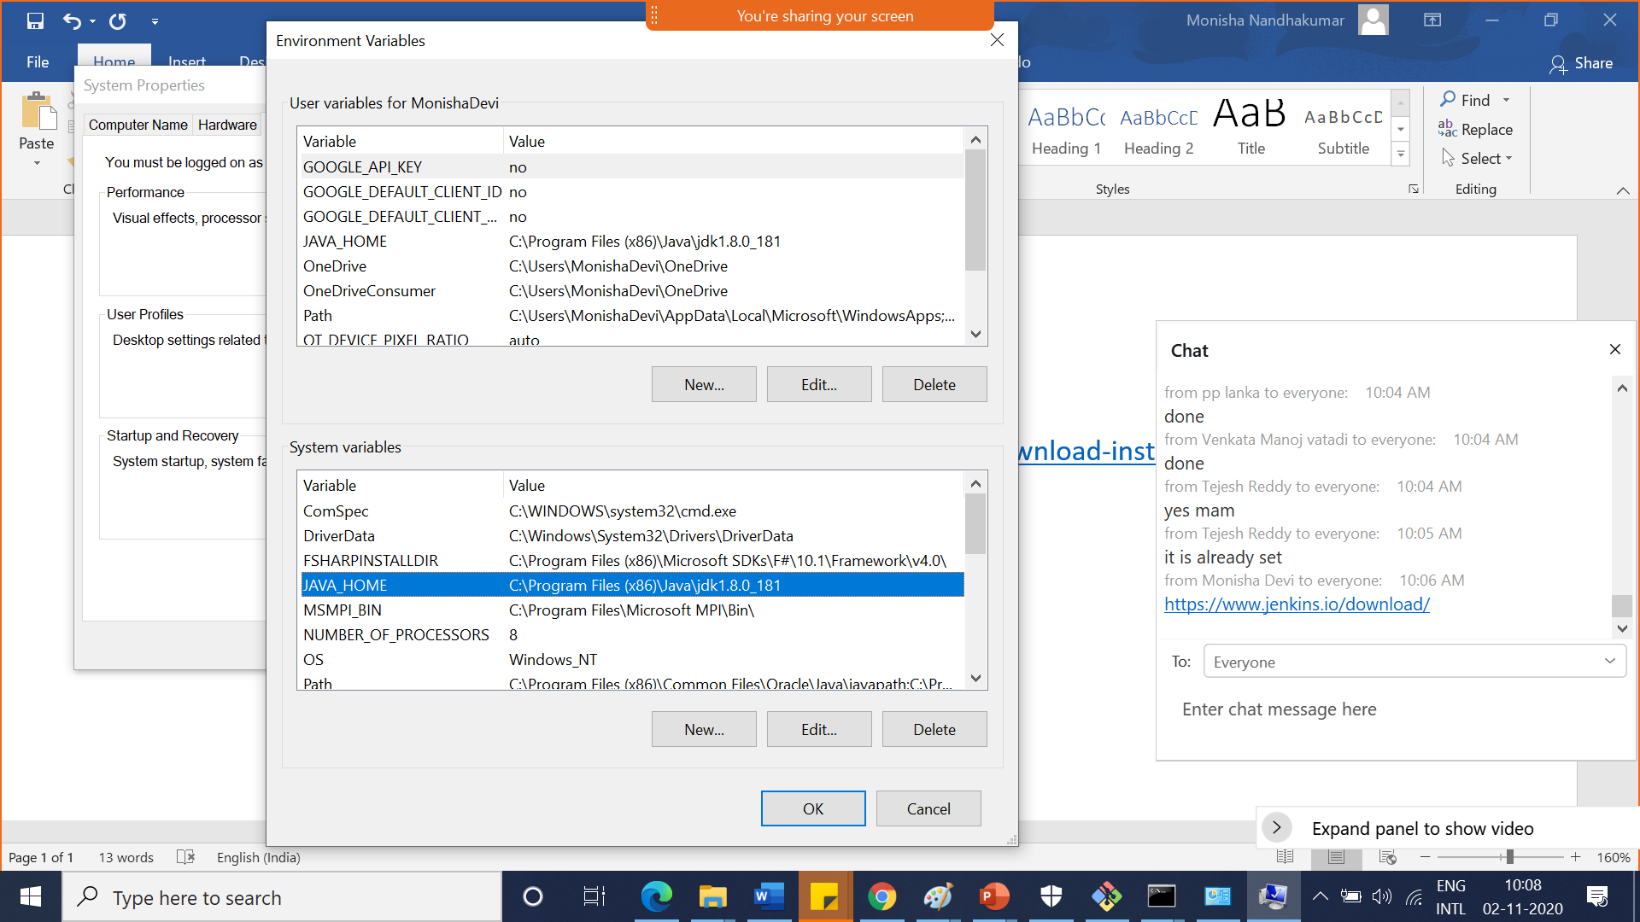

3.Download Jenkins.war : <https://www.jenkins.io/download/>

4.Create a folder (Jenkins) in c drive🡪Program files🡪paste war file inside jenkins dolder

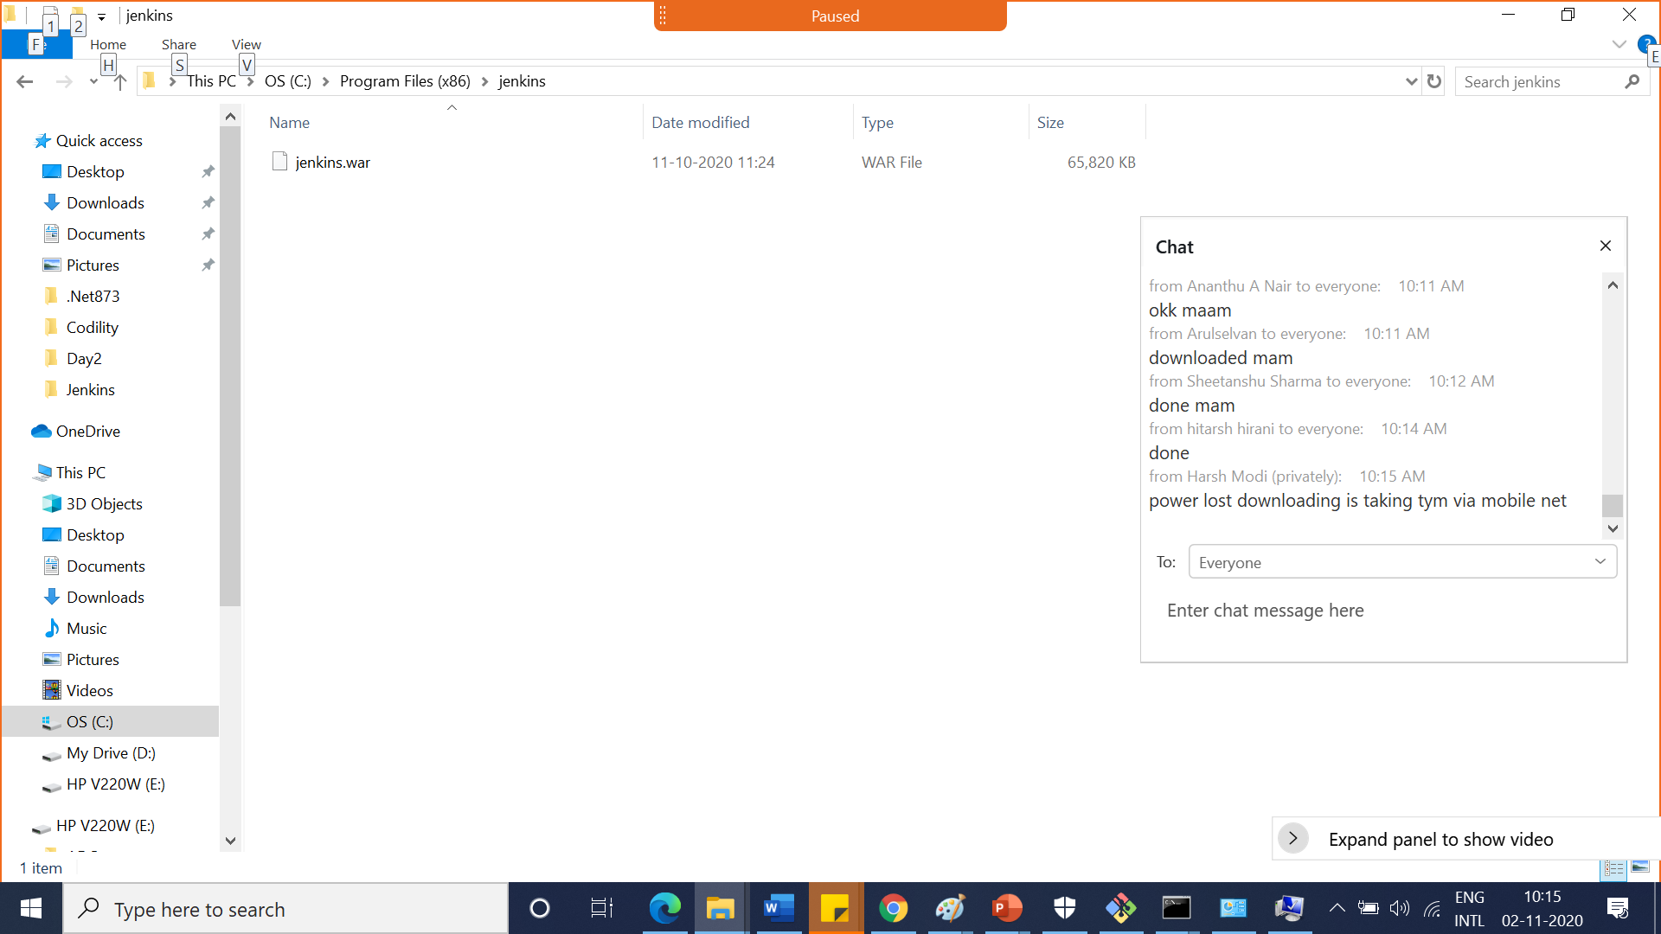

5.In cmd Migrate to the part where jenkins war is present then type the below command

java -jar jenkins.war --httpPort=8090

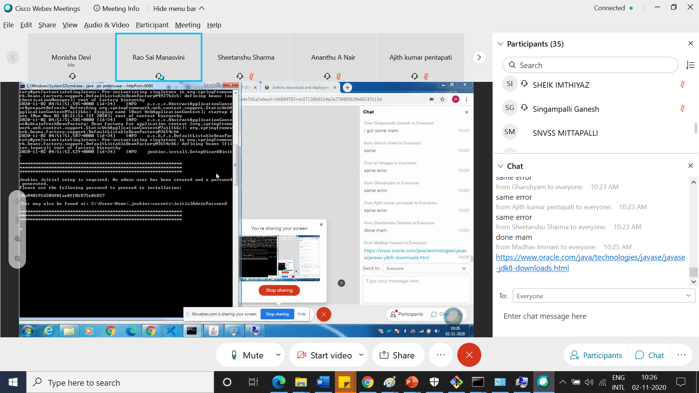

Password is generated

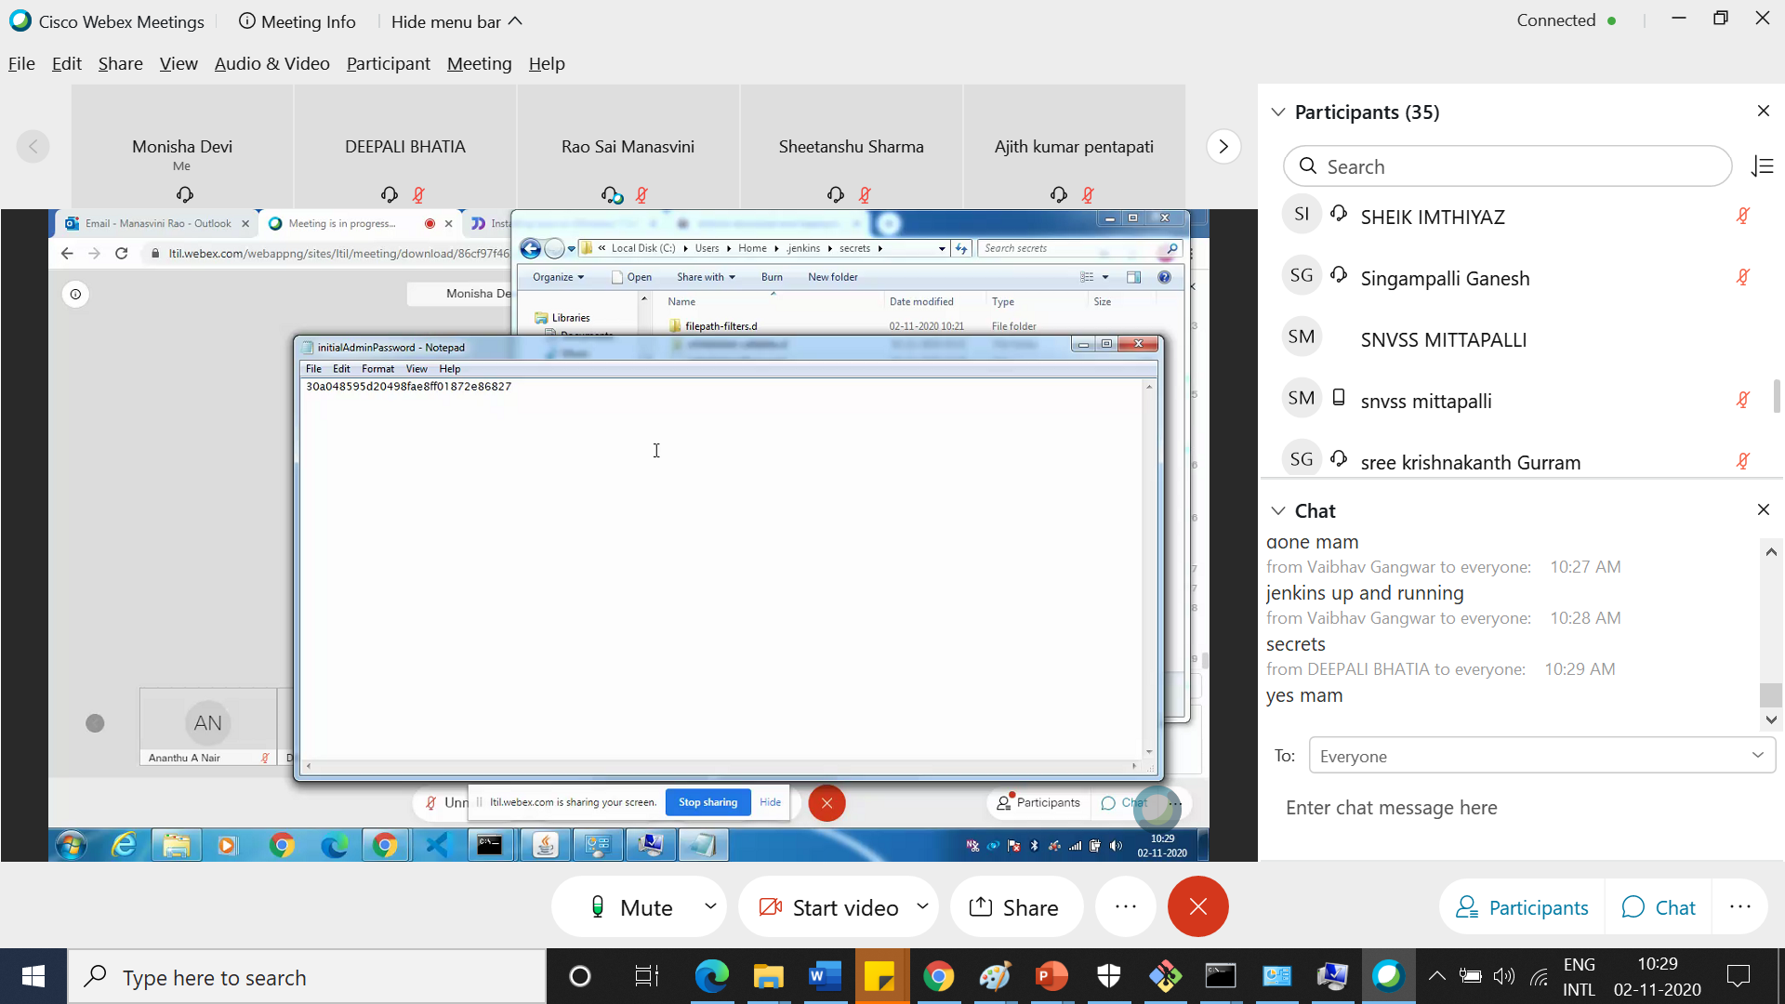

Go to browser localhost8090

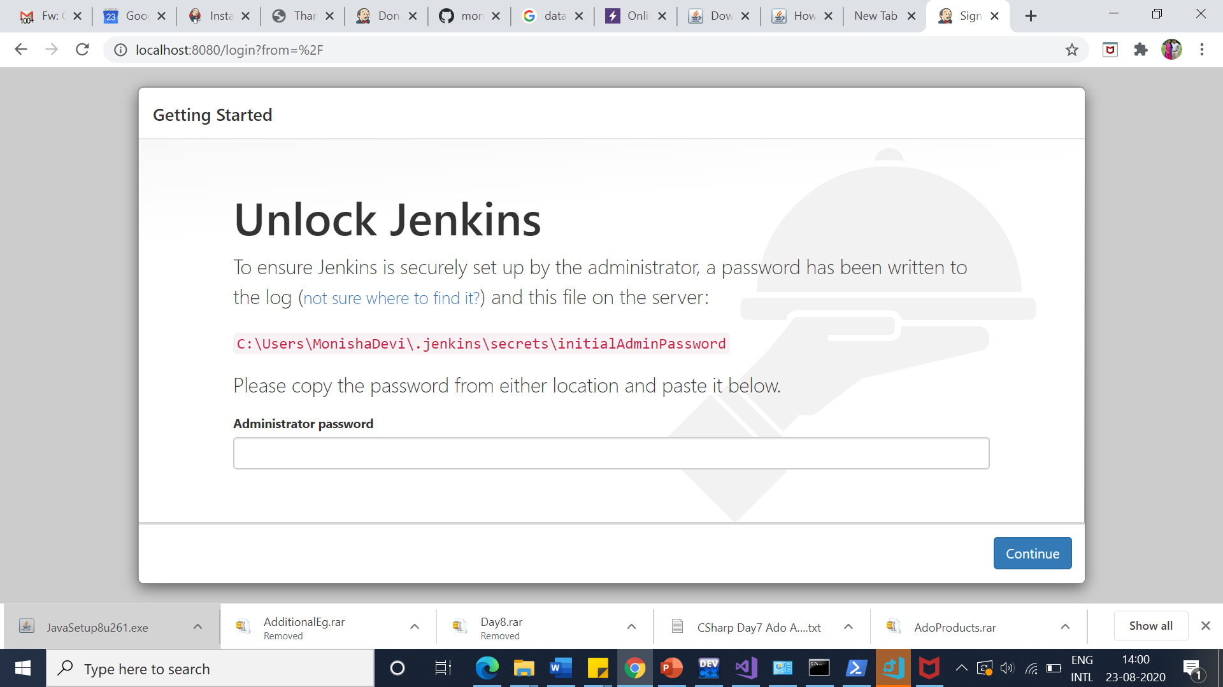

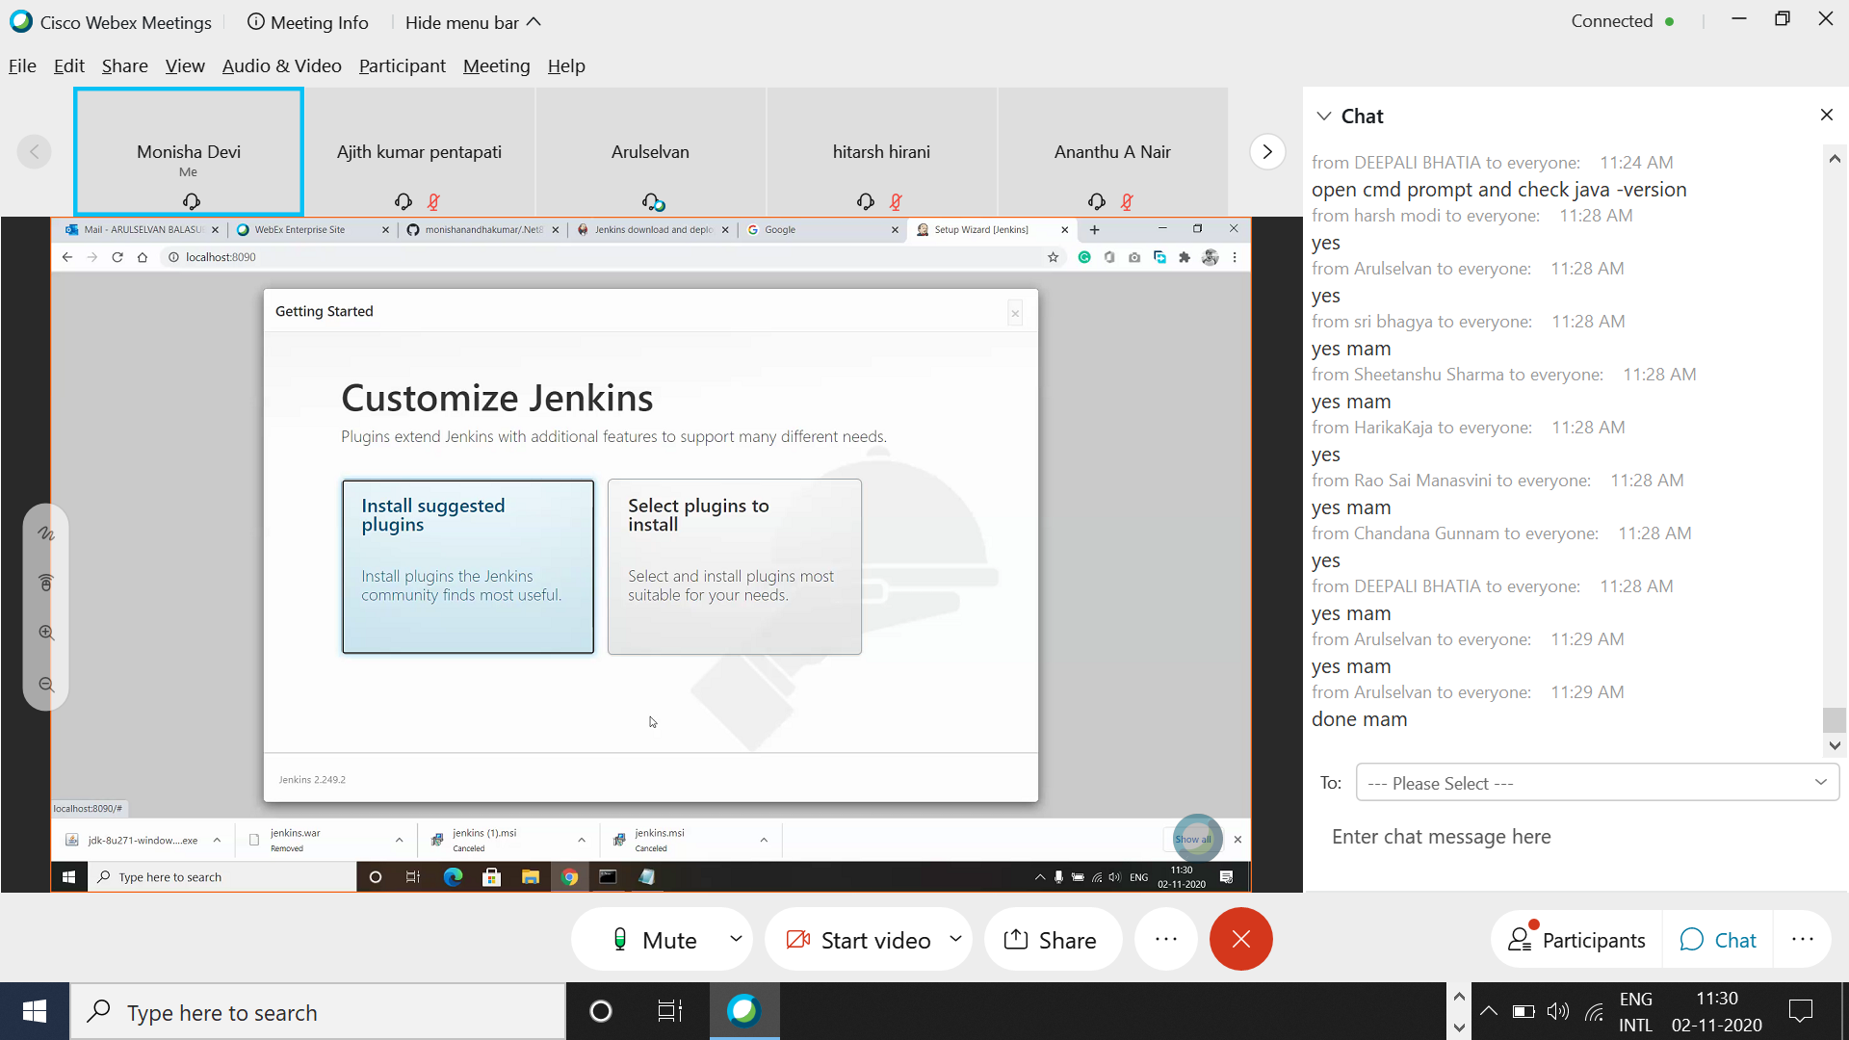

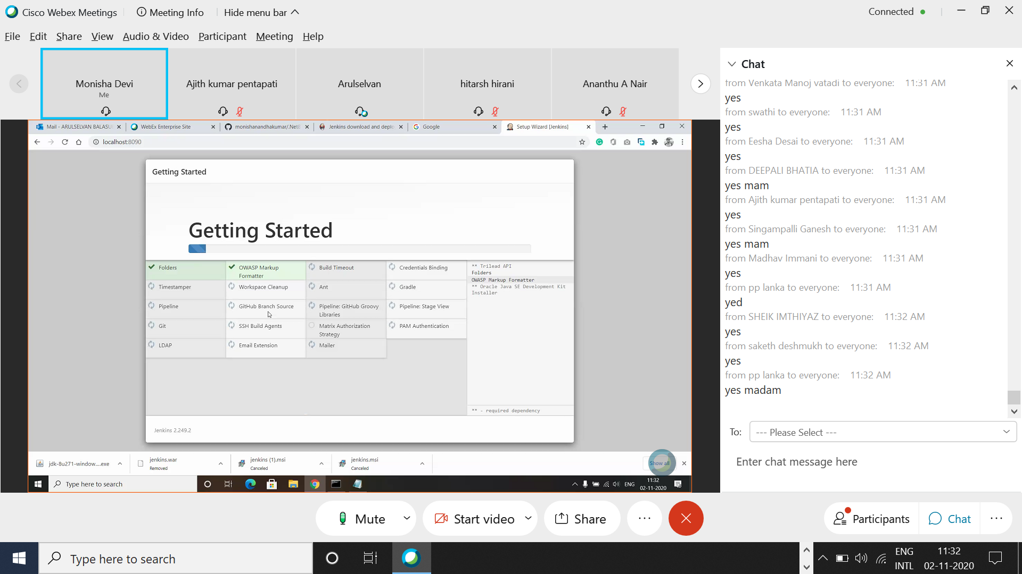

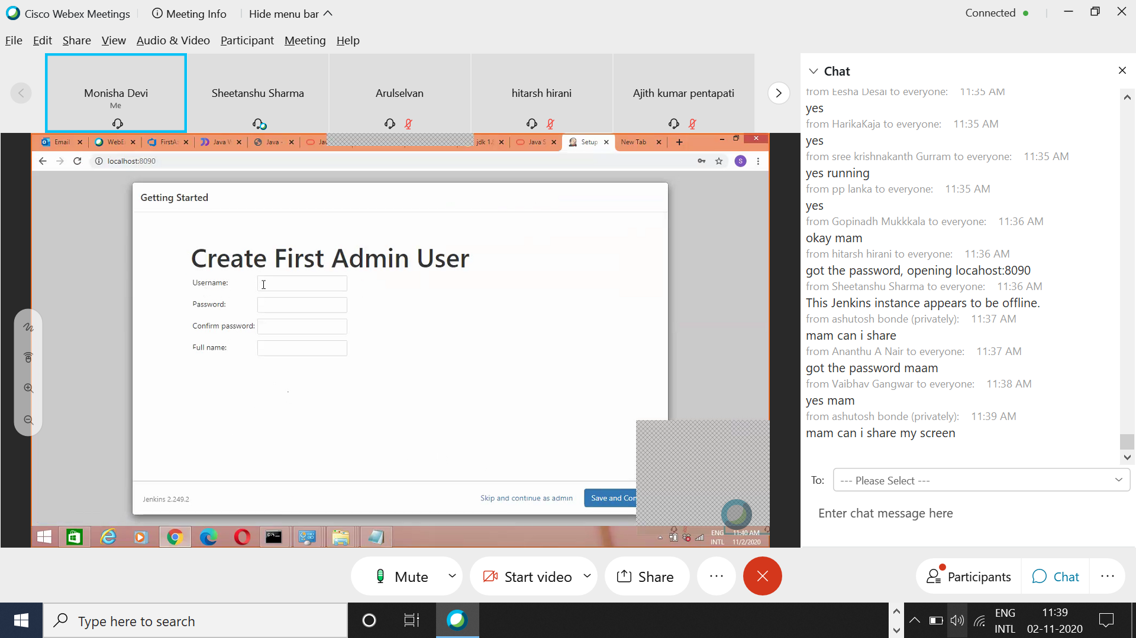

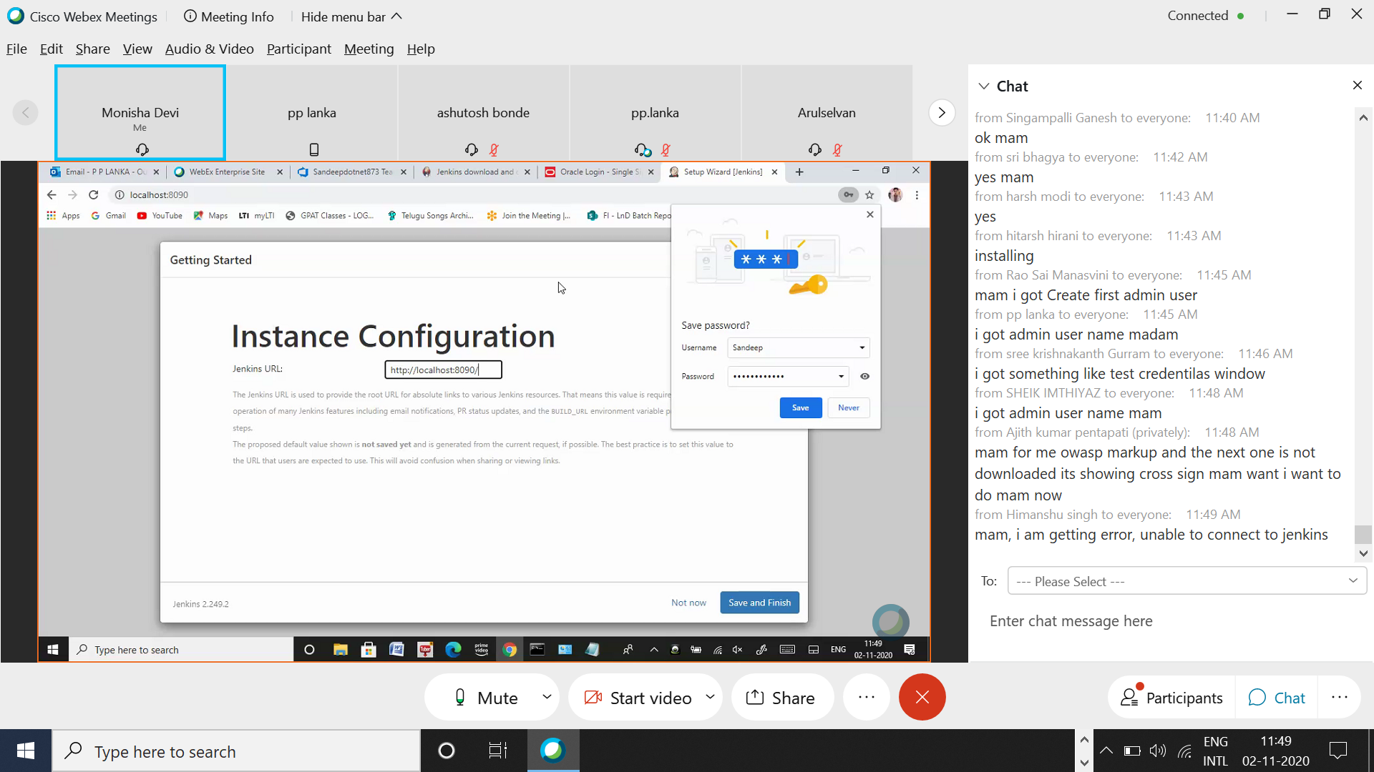

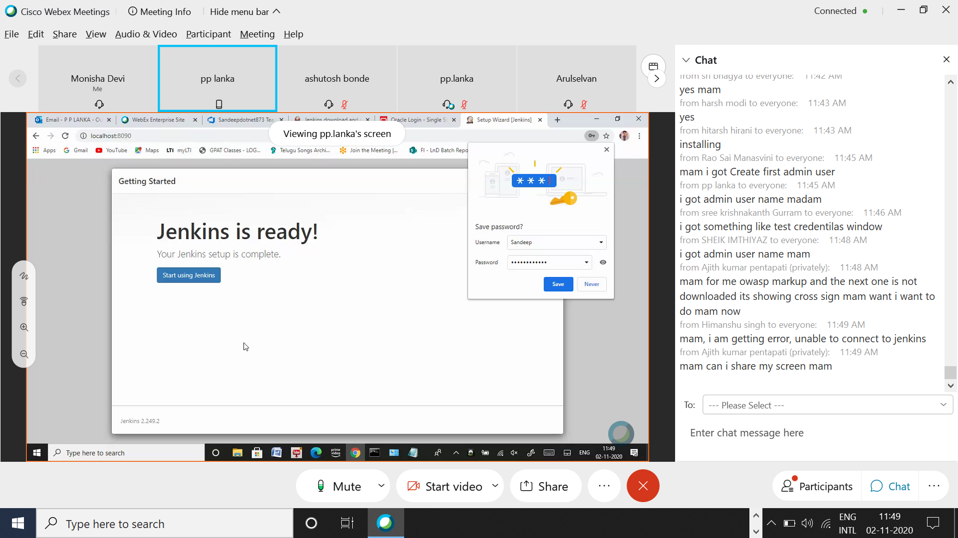

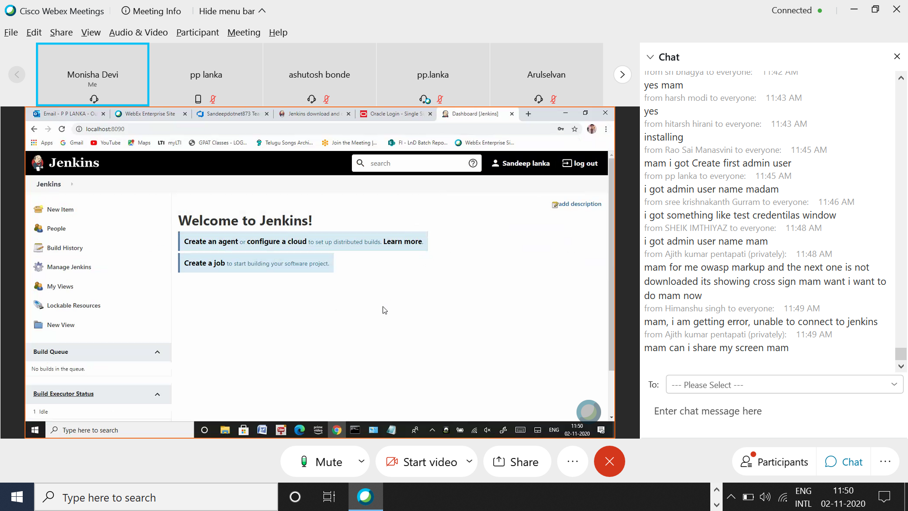

Click new Item

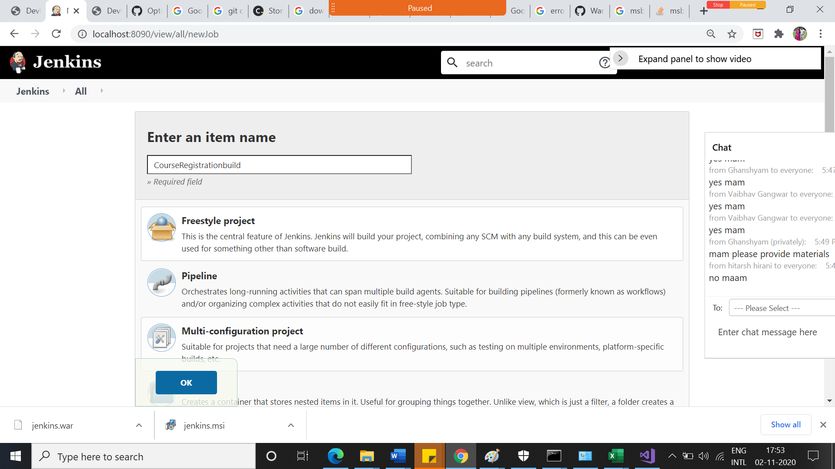

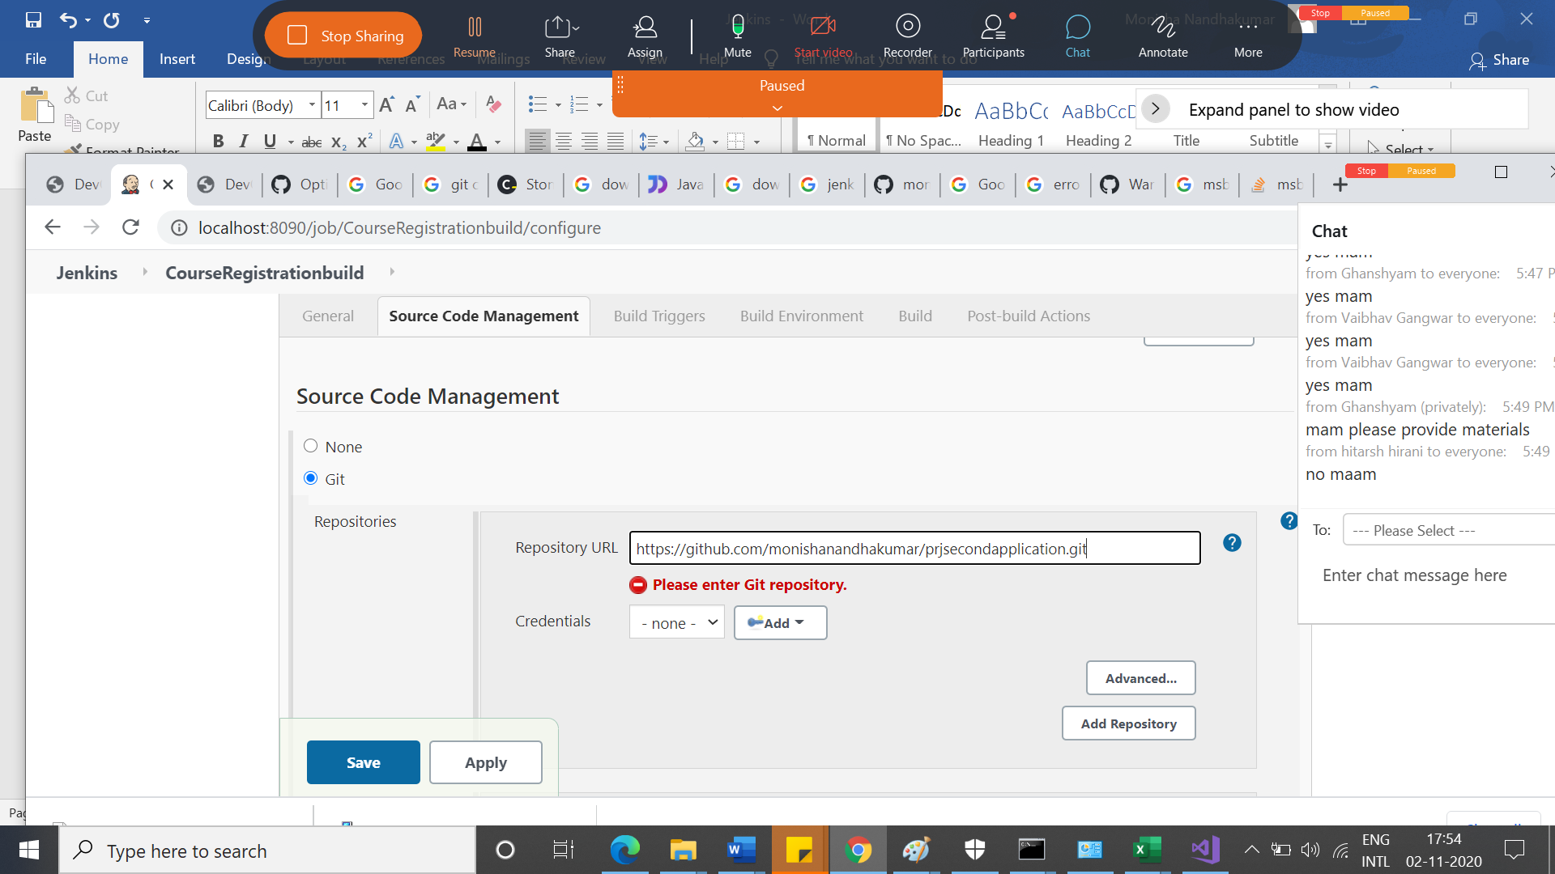

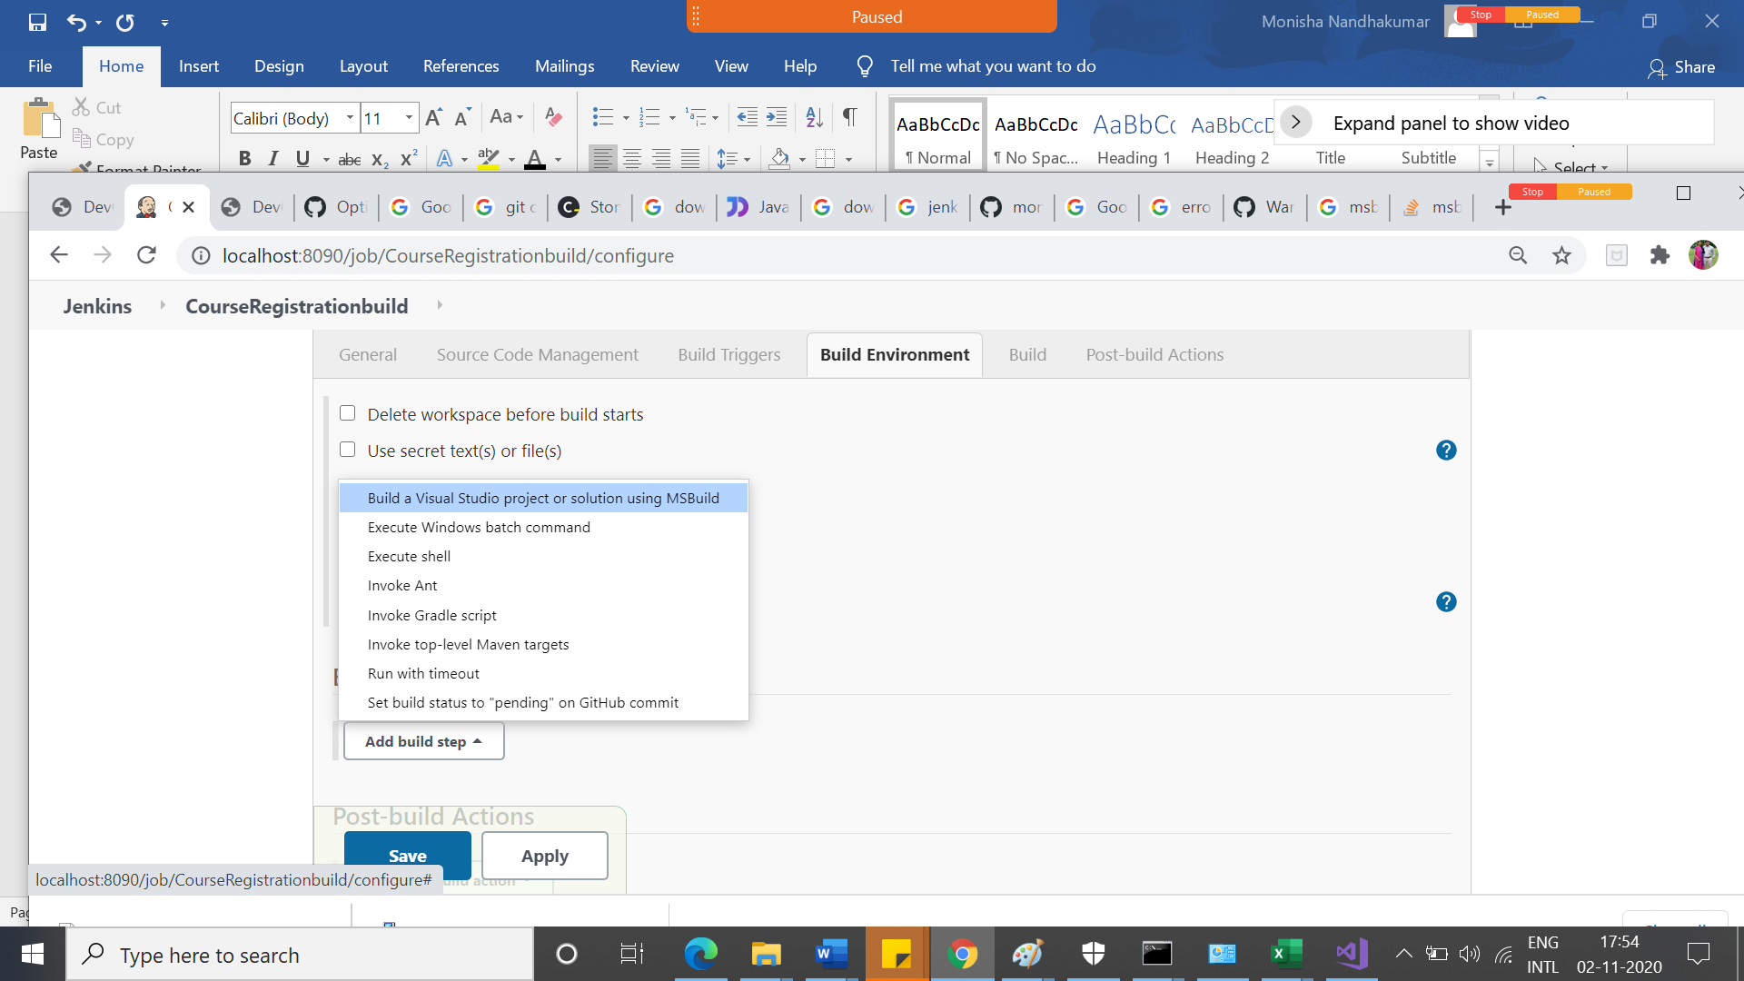

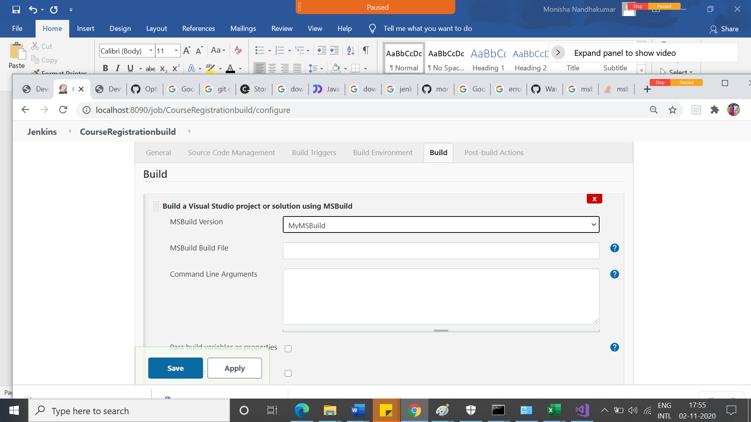

Build and see the console output

InJenkins🡪ManageJenkins🡪globalconfiguration🡪Msbuildpath

